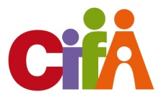
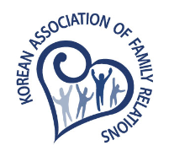

The 5th Regional Symposium of CIFA in 2016
Asian Families: Change and Consistency
November 3 - 5, 2016, Seoul, Korea

Submission of the Abstract

Title |  |  |  |  |  |  |  |  | Please tick () your presentation for:
 |  |  |  |  |  |  |  |  | Concurrent Session Presentation ( )
 |  |  |  |  |  |  |  |  | Poster Session Presentation ( )
Information of Author(s)
 |  | Name |  |  |  |  | Country | Position / Affiliation
1
2
3
4
Corresponding Author |  |  |  |  | Name
 |  |  |  |  | Address
 |  |  |  |  | e-mail |  |  |  |  | Tel.
Please indicate category(s) for your presentation (please tick one or more fields )
1 |  |  | Family Relations and Family Harmony: Changing Values in Asia
2 |  |  | Families with Special Needs
3 |  |  | Child Development and Parenting in Asian Families
4 |  |  | Family Life Education
5 |  |  | Changing Roles of Elderly Members in Contemporary Families
6 |  |  | Domestic Violence: Interventions and Mediation
7 |  |  | Family Therapy and Practice Wisdom
8 |  |  | Family Policy Initiatives in Responding to Changing Family Needs

Title: | 12pts bold
Contents of Abstract  (should be written in English with maximum to 200 words) | 12pts
Keywords (3~5 words)
 | 12pts bold
Category(ies)
 | 12pts

Please submit your abstract by e-mail to cifa2016seoul@gmail.com latest on 30th June, 2016

